

MS Word Training - Session 2

Activity & Exercise
Version: 1.0
February, 2009
Copyright Information:
This document is the sole property of AIG Inc. All rights reserved. No part of this document may be reproduced, stored in a retrieval system, translated, transcribed, or transmitted in any form or by any means, without the prior written permission of AIG Systems Solutions (AIGSS).
Document Information
S.No | Document Title | Base Version No. | Author | Contact Email ID | Date Of Release
1 | MS Word Training – Session 2 Activity & Exercise | 1.0 | Deepika Datta | deepika.datta@aig.com | February, 2009
Revision History
S.No | Version No. | Date Of Release | Author (s) | Affected Section(s) | History of Changes | Approver

Table of Contents
1 Activity 4
1.1 Task 1 – Indents, bullets and numbering 4
1.2 Task 2 – Tables 4
1.3 Task 3 – Inserting images 4
1.4 Task 4 – Working with images 5
1.5 Task 5 – Editing images 6
1.6 Task 6 – WordArt 6
1.7 Task 7 – Formatting tables 7
1.8 Task 8 – Converting text to tables and sorting 8
1.9 Task 9 – Columns 9
2 Exercise 10
2.1 Exercise 1 – Indents 10

Activity

Task 1 – Indents, bullets and numbering
You can set indents in the following by changing the appropriate values in the Paragraph dialog box or by positioning the Indent markers on the horizontal ruler.
- Open the indents-bullets-numbering.doc file.
- Indent the first paragraph before the text by 1cm.
- Indent the second paragraph both before and after the text by 2cm.
- Indent just the first line of the third paragraph.
- Add a hanging indent to the fourth paragraph.
- Add bullet points to the list of fruit below the fourth paragraph.
- Add numbering to the list of colors at the bottom of the page.
- Identify the markers on the ruler bar which control: the left indent, the first line indent, the hanging indent and the right indent.

Task 2 – Tables
- Create a new document, and insert a table with 4 columns and 3 rows.
- Adjust the width of the columns:
Set Column 1 to 2.16 cm (1"),
Set Column 2 to 3.43 cm (1.5"),
Set Column 3 to 2.16 cm (1"),
Set Column 4 to 1.54 cm (0.6").
- Save it as hotel2.doc.
- Add the following data to the table.
Resort | Hotel | Rooms | Rating
Bermuda | Elbow Beach | 300 | *****
Gambia | The Heights | 204 | ****

- Modify the table to include an extra column between Rooms and Rating and an extra row at the bottom. Enter the title Price £pppn, and enter the data as shown below.
Resort | Hotel | Rooms | Price £pppn | Rating
Bermuda | Elbow Beach | 300 | 600 | *****
Gambia | The Heights | 204 | 350 | ****
India | Fort Aguada | 250 | 220 | ****

- Format all headings so they are bold and centred. Re-size columns where necessary to accommodate the text.
- Format the Rooms data and Price £pppn data so that the numbers are right aligned and centre the stars in the Rating column.
- Save changes.

Task 3 – Inserting images
- Open a blank word document.
- Use the clip organiser to locate an image of a plant.
- Insert your chosen clip art image.
- Insert Caption and label it.
- Save the file as ForTask4.doc.
- Close the document.

Task 4 – Working with images
- Open ForTask4.doc
- Set the size and position of the first image (the one in the second paragraph) using the Format Picture dialog box as follows:
- Set the width of this image to approximately 5 cm, ensuring the height/width ratio is maintained relative to the original picture size.
- Set the wrapping style to Tight and position it on the right of the second paragraph.
- Set the distance from text to 0.5 cm and allow the text to wrap on the largest side only.
- Set the object to move with text. Do not lock the anchor, but allow other objects to overlap.
- Set the size and position of the second image, using the Format Picture dialog box as follows:
- Set the width of this image to approximately 8 cm, ensuring the height/width ratio is maintained relative to the original picture size.
- Set the wrapping style to Top and Bottom and position it horizontally in the centre.
- Set the distance from text above and below the image to 0.5 cm.
- Set the object to move with text. Do not lock the anchor, but allow other objects to overlap.
- Close the Format Picture dialog box, then position the image just above the heading Early to mid-summer-flowering clematis.
- Set the size and position of the third image, using the Format Picture dialog box as follows:
- Set the height of this image to approximately 8 cm, ensuring the height/width ratio is maintained relative to the original picture size.
- Set the wrapping style to Square.
- Set the Horizontal Alignment to Right - Margin and the Vertical Alignment to Bottom-Margin.
- Set the distance from text above and left of the image to 0.5 cm, and bottom and right to 0cm.
Note: As the object is aligned to the margin, it will not be able to move with text.
- Allow other objects to overlap.
- Insert a picture file clematis4.jpg (from Activity Folder) at the end of the heading Late summer to early autumn-flowering clematis.
- Using the Format Picture dialog box format the picture as follows:
- Set the width of this image to approximately 2 cm, ensuring the height/width ratio is maintained relative to the original picture size.
- Ensure the wrapping style is set to In line with text.
- Close the Format Picture dialog box and check that the picture is position at the end of the heading, with two character spaces between the text and the image.
- Make a copy of the second image and place it somewhere in the centre of the section on Growing Tips on page 3.
- Set the width of this image to approximately 4 cm, ensuring the height/width ratio is maintained relative to the original picture size.
- Set the text to wrap tightly around the shape of the image.
- Save your document as ForTask5.doc and leave it open for the next exercise.

Task 5 – Editing images
- With the previous exercise open on your screen (Task 3), edit the images as detailed below:
- Rotate the second image to the left by 90°.
- Place a Gold border around this image with a weight of 5pt.
- Change the third image (the small one) to black and white.
- Make the fourth image brighter.
- Place a border of your choice around this image.
- Save your document as Task 3.doc and close it.

Task 6 – WordArt
- Create a similar looking document as the image below.

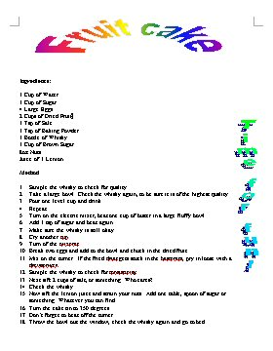

Task 7 – Formatting tables
- Open the file Formatting tables 1.doc.
- Insert a new column on the right of the table.
- Add the data shown opposite to the last column:
- Insert a new row at the top of the table.
- Merge the cells in the new first row and add the heading IT Courses.
- Apply shading to the first row.
- Merge the first 2 cells in the second row together. What has Word done to the data in these cells?
- Undo your last change.
- Remove all the borders from your table.
- Show the gridlines.
- Apply a double border around the outside of your table.
- Centre the headings in row 2.
- Centre the data in the 4th column.
- Set a decimal tab to line up the figures in the last column.
- Use the AutoFit to contents feature to adjust the column widths.
- Open Formatting Tables 2.doc.
- Copy and paste this table into your first document, below your existing table.
- Delete the first two rows of the second table.
- Join your two tables together.
- Adjust the column widths and borders as necessary to make the new rows you have added look like part of the top table. You may also need to adjust the decimal tab in the last column.
- Set a top cell margin of 0.1cm and bottom cell margin of 0.05cm.
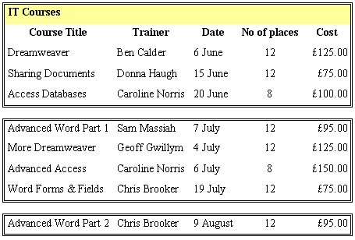
- Split your table into 3 separate tables, one for each month.
- Your final tables should look like the example opposite (the column widths may vary).
- Apply an AutoFormat of your choice.
- Save your document as Task3.doc and close it.

Task 8 – Converting text to tables and sorting
- Open Formula 1.doc.
- Convert the tabulated data into a Word table.
- Sort the table in alphabetic order by Team (column 4).
- Use AutoFit to Contents to resize the columns widths.
- Save your document as Task4.doc and close the file.

Task 9 – Columns
- Open the document Bentham.doc.
- Use the Columns button on the toolbar to display the document in two columns.
- Select the main heading and the following blank line and format it as one column, thus making the column on the right start level with the left-hand column.
- Change your left and right page margins to 2cm. (Remember to set this for the Whole document, as your document has now been divided into 2 sections.)
- Using the Columns dialog box, make the column on the left 9cm, the column on the right 7cm and the space between the columns 1cm.
- On the last line of the document, change the space between Dr and Jonathan and Harris to pad spaces (delete the spaces and hold down both the Shift and Ctrl keys whilst pressing the Space Bar). This will keep Dr and Jonathan and Harris on the same line.
- Place a column break before the heading The Auto-Icon.
- Place a vertical line between the columns.
- Balance the end of the columns on the second page.
- Save as Task5doc and close it.

Exercise

Exercise 1 – Indents
- Follow the instructions to create the document as shown below.
- Use the Garamond font, point size 14 for the document.
- Enter the heading and format it using bold.
- Move to the line where the first heading Aims is positioned. Set the Hanging Indent marker on the ruler bar at 5.5cm approximately.
- Type the text Aims and press the Tab key once. Type the text shown. Notice that the text automatically wraps to the new line.
- Repeat Step 5 above for each of the headings shown.
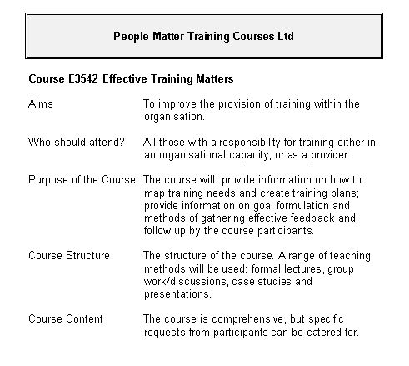

- Enter the contact details at the bottom of the text:
- Format the text you have just entered in step 7 using bold and italic.
- Insert a new title at the top of the document:
People Matter Training Courses Ltd.
- Centre the heading, and format it using Helvetica Bold, 14 point. Place a double border box around the title and shade the area using 10% grey.
- Save the file as people.doc.

